Expt No:  03 | TRAFFIC LIGHT CONTROL SYSTEM
Date:
/ /2025

- AIM:
To implement a one way and two-way traffic light control system.
- ONE WAY DIRECTION:

  - PROBLEM STATEMENT:

Red light glows for 30s, yellow light for 5 s, green light for 25s and this process continues. There is a start button and a stop button. Draw the ladder logic to implement the above process.

  - FLOW DIAGRAM:

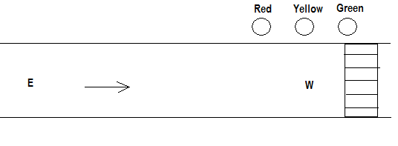
Figure 2.1. one way traffic light control system.

  - LADDER DIAGRAM:

- TWO-WAY DIRECTION:

  - PROBLEM STATEMENT:

When Red 1 is ON for 30s, E-W traffic flows. At this instant, Yellow 2 becomes ON for 5s after which Green 2 becomes ON for 25s. After 30s, when Red 2 is ON for 30s, N-S traffic flows. At this instant, Yellow 1 becomes ON for 5s after which Green 1 becomes ON for 25s and this process continues. There is a start button and a stop button. Draw the ladder logic to implement the above process.

  - FLOW DIAGRAM:

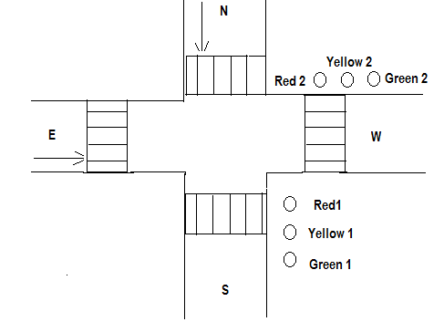
Figure 3.1. two-way traffic light control system.

  - LADDER DIAGRAM:

- RESULT:
Thus, the one way and two-way traffic light control was executed and verified using PLC.

